Hiyab Mengisteab
Task 1: Data Processing Solution

Part I: Business Case Analysis

A. Business Case Overview

1. Problem Statement
Precision Components Inc., a manufacturing firm specializing in components for the automotive supply chain, is undergoing a significant transformation due to a recent acquisition (SmallFirm, Inc.), accelerated business growth, and planned international expansion.
However, the company’s current data infrastructure is fragmented and inefficient, with disparate systems including MS Access databases, Excel spreadsheets, an on-premise SQL Server-based ERP system, and a hosted Oracle-based HR/payroll system. Reporting is siloed and lacks a centralized view, impeding strategic decision-making, especially during mergers and competitive shifts.
Business Requirements:
- Cleanse and merge data from SmallFirm, Inc. into the existing ERP and HR systems.
- Ingest new data on a daily or nightly basis.
- Integrate all enterprise systems into a unified data warehouse.
- Enable real-time dashboards and reporting.
- Support global scalability and system interoperability.
- Unify siloed sales data for a comprehensive performance view.
- Ensure compliance and data security.

2. Source-to-Target Data Mapping
a. Define the Attributes

Payroll (MS Access) | Payroll records
Attribute | Description
ID | Unique identifier for each payroll record.
EmployeeId | Foreign key linking to the Personnel table; identifies which employee the payroll entry is for.
Salary | The amount paid to the employee, typically for a pay period.
PayDate | The date the salary was issued or paid.
Personnel (MS Access) | Employee information
Attribute | Description
ID | Unique identifier for each employee.
FirstName | Employee’s first name.
LastName | Employee’s last name.
Position | Job title or role of the employee.
HireDate | The date the employee was hired.
Vendors (MS Access) | Vendor profiles
Attribute | Description
ID | Unique identifier for each vendor.
Name | Name of the vendor company.
AccountRep | Name or ID of the vendor’s representative responsible for the account.
Status | Indicates whether the vendor is active, inactive, approved, or pending.
Products (Excel) | Product catalog
Attribute | Description
ProductID | Unique identifier for each product.
Name | Name of the product.
Cost | The internal cost to produce or acquire the product.
SalePrice | Price at which the product is sold to customers.
RawMaterials | Materials required to produce the product (could be a list, code, or reference).
Tooling | Tools or equipment required for producing the product (may reference tooling inventory).
Production Batch Details (Excel) | Manufacturing output
Attribute | Description
BatchNumber | Unique identifier for each production batch.
ProductionDate | Date when the batch was produced.
ProductID | Foreign key linking to the Products table; identifies what product was produced.
QuantityProduced | The number of units produced in this batch.
Tooling Inventory (Excel) | Tooling stock
Attribute | Description
ID | Unique identifier for each tool in the inventory.
ToolName | Name or description of the tool.
Quantity | Number of available units for this tool.
Location | Storage or usage location of the tool.
Cost | Cost of purchasing or replacing the tool.
RestockLevel | Minimum acceptable quantity before needing to reorder.
VendorID | Foreign key linking to the Vendors table; identifies the supplier of the tool.
Raw Materials Inventory (Excel) | Material stock levels
Attribute | Description
ID | Unique identifier for each raw material entry.
MaterialName | Name or description of the raw material.
Quantity | Quantity available in inventory.
Unit | Unit of measurement (e.g., kg, liters, pieces).
RestockLevel | Minimum stock threshold triggering a reorder.
VendorID | Foreign key linking to the Vendors table; identifies the supplier of the raw material.

b. Attribute Mapping (Example Subset)

Table A | Attribute (Table A) | Table B | Attribute (Table B) | Relationship Type | Transformation Required
Personnel | ID | Payroll | EmployeeId | One-to-Many | Rename Personnel.ID to EmployeeId in mapping
Vendors | ID | Tooling Inventory | VendorID | One-to-Many | Rename Vendors.ID to VendorID
Vendors | ID | Raw Materials Inventory | VendorID | One-to-Many | Rename Vendors.ID to VendorID
Products | ProductID | Production Batch Details | ProductID | One-to-Many | N/A (already aligned)
Tooling Inventory | ID | Products | Tooling | One-to-Many / Many-to-Many | Normalize Tooling if it stores multiple tools
Raw Materials Inventory | ID | Products | RawMaterials | One-to-Many / Many-to-Many | Normalize RawMaterials if it stores multiple items

c. Necessary Data Transformations
From Table | Original Attribute | Data Transformation | Why
Personnel | ID | New Name : EmployeeId | To match with Payroll.EmployeeId as foreign key
Vendors | ID | New Name : VendorID | To link with Tooling Inventory and Raw Materials Inventory
Personnel | HireDate | Data type : DateTime | Enables sorting, filtering, date math

Part II: Recommended Design Solution

B. Data Engineering Design

1. Process Flow Diagram Description
Step-by-Step Flow:
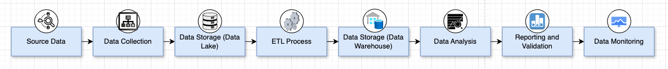
Step | Component | Description
1 | Resource Data | Raw data from Excel, Access, or other company sources
2 | Data Collection (AWS Glue) | Import raw data
3 | Data Lakehouse (Amazon S3) | Raw and semi-structured data stored in S3
4 | ETL Process (AWS Glue Jobs) | Data is cleaned, transformed, normalized, and enriched
5 | Data Warehouse (Amazon Redshift) | Transformed data is loaded into Redshift for querying and analysis
6 | Data Analysis | Analysts or tools perform queries, ML, or aggregations
7 | Reporting and Validation | Dashboards and validation checks (e.g., QuickSight, Great Expectations)
8 | Data Monitoring | Logs, alerts, metrics via CloudWatch, SNS, Deequ, etc., ensure pipeline health

Diagram:
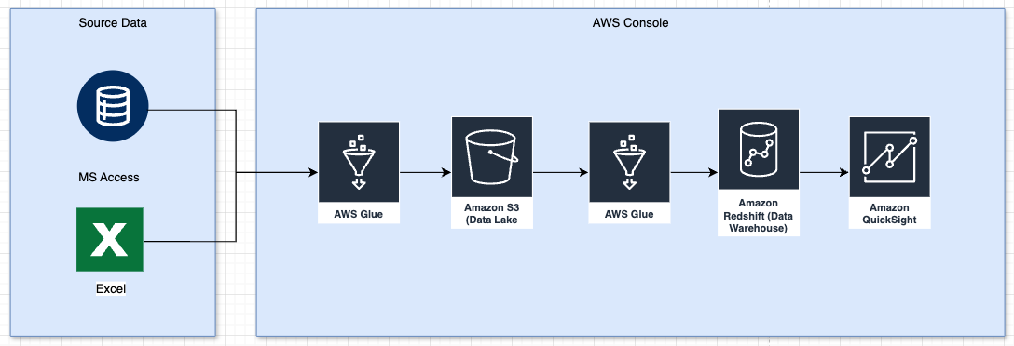

Step | Component | Function
1 | Excel/MS Access | Source systems containing raw data
2 | AWS Glue ETL (1) | Extract and clean data, write to S3
3 | Amazon S3 | Acts as a central data lake
4 | AWS Glue ETL (2) | Transform and load data into Redshift
5 | Amazon Redshift | Data warehouse for analytics and reporting
6 | Amazon QuickSight | BI tool for visual dashboards

Part III: Processing Design Evaluation

C. Stakeholder Relevance

1. Advantages of the AWS-Based Design

Scalable and Cost-Efficient
  - AWS offers a pay-as-you-go model with elastic compute and storage.
  - Redshift and Glue scale with data growth, ideal for planned international expansion.
- Unified and Real-Time Analytics
  - Redshift centralizes all data sources for holistic reporting.
  - QuickSight allows fast dashboard deployment with real-time visibility.
- Serverless and Low Maintenance
  - AWS Glue and Redshift Serverless minimize infrastructure management.
  - Enables focus on data quality and insights rather than managing hardware.
- Security and Compliance
  - Native tools like IAM, KMS, Macie provide robust security and compliance capabilities.

2. Disadvantages of the AWS-Based Design
- Learning Curve and AWS Expertise Required
  - Teams will need to learn AWS Glue, Redshift, and IAM roles.
  - Might require training or hiring AWS-savvy engineers.
- Vendor Lock-In
  - Heavy investment in AWS ecosystem can increase dependency.
  - Future migration to other cloud platforms may be complex.
- Migration Complexity
  - Migrating from legacy systems like MS Access and Excel could require significant cleaning and restructuring.
  - Data inconsistencies may require more manual intervention than automated tools can provide.

Reference:
- External resources not used in this submission

